**Terraform Getting Started Guide**

**Introduction to Terraform**

Terraform is an open-source Infrastructure as Code (IaC) tool developed by HashiCorp. It allows you to define, provision, and manage infrastructure using a declarative configuration language called HCL (HashiCorp Configuration Language).

**Why Use Terraform?**

* **Cloud Agnostic:** Terraform works with multiple cloud platforms like AWS, Azure, Google Cloud, and more.
* **Version Controlled:** You can track infrastructure changes using Git, providing version control and collaboration.
* **Reusable:** With modules, you can standardize and reuse infrastructure across multiple projects.
* **Automated:** Terraform allows consistent and automated application of infrastructure changes.

**Key Concepts**

* **Infrastructure as Code (IaC):** IaC is the practice of managing and provisioning infrastructure through code rather than manual processes. It allows automation, repeatability, and version control for cloud setups.
* **Providers:** These are plugins that interact with cloud platforms and services (e.g., AWS, Azure).
* **Resources:** The infrastructure elements like EC2 instances, S3 buckets, etc.
* **Modules:** Reusable and shareable configurations.
* **State:** Terraform maintains a state file that tracks the infrastructure it manages.

**What Does "Provision" Mean?**

Provisioning means creating and preparing infrastructure resources for use. In Terraform:

* **Define =** Writing infrastructure definitions in .tf files.
* **Provision =** Terraform creates the resources.
* **Manage =** Terraform updates or deletes the resources as defined in the configuration.

**Terraform Installation**

**For Linux**

When setting up Terraform on my Linux machine, I follow these steps:

1. **Update and Install Dependencies**  
   I update my package list and install the required dependencies using the following command:

sudo apt-get update && sudo apt-get install -y gnupg software-properties-common curl

1. **Add the HashiCorp GPG Key**  
   I add the HashiCorp GPG key, which is necessary to verify the repository:

curl -fsSL https://apt.releases.hashicorp.com/gpg | \

sudo gpg --dearmor -o /usr/share/keyrings/hashicorp-archive-keyring.gpg

1. **Add the HashiCorp Linux Repository**  
   I add the repository to my system:

echo "deb [signed-by=/usr/share/keyrings/hashicorp-archive-keyring.gpg] \

https://apt.releases.hashicorp.com $(lsb_release -cs) main" | \

sudo tee /etc/apt/sources.list.d/hashicorp.list

1. **Install Terraform**  
   I install Terraform by updating the package list and running:

sudo apt update

sudo apt install terraform

1. **Verify Installation**  
   Finally, I ensure Terraform is installed correctly by checking its version:

terraform -v

**For Windows**

For my Windows setup, I follow these steps:

1. **Download Terraform**  
   I visit the official Terraform download page: [Terraform Downloads](https://www.terraform.io/downloads) and download the appropriate version for Windows (for example, terraform_1.6.5_windows_amd64.zip).
2. **Extract the ZIP File**  
   After downloading, I right-click on the ZIP file and choose **Extract All**. I select a destination folder such as C:\Terraform where I want to keep the files. After extraction, I make sure that terraform.exe is in that folder.
3. **Add Terraform to System PATH**  
   To use Terraform from any Command Prompt or PowerShell window, I add its folder to the PATH:
   * I open **Environment Variables** from the Start menu.
   * Under **System Variables**, I find and select the **Path** variable and then click **Edit**.
   * I add the path C:\Terraform (or the folder where terraform.exe is located).
   * I click **OK** to confirm the changes.
4. **Verify Installation**  
   I open a new Command Prompt or PowerShell window and run:

terraform -v

I expect to see the installed Terraform version displayed.

**Terraform Configuration and Syntax**

My configuration files are written in HCL (HashiCorp Configuration Language). Here’s how I structure my project:

**Typical Project Structure**

my-terraform-project/

├── main.tf # Main configuration

├── variables.tf # Input variables

├── outputs.tf # Output values

**Providers**

I define the cloud provider like this:

provider "aws" {

region = "us-east-1"

}

**Resources**

I add resources to create infrastructure. For example, to create an EC2 instance:

resource "aws_instance" "example" {

ami = "ami-0c55b159cbfafe1f0"

instance_type = "t2.micro"

}

**Variables**

I use variables to make my configurations dynamic:

variable "instance_type" {

description = "Type of EC2 instance"

default = "t2.micro"

}

**Outputs**

I define outputs to extract valuable information after provisioning:

output "instance_ip" {

value = aws_instance.example.public_ip

}

**SYNTAX**

**✅ terraform block**

terraform {

required_providers {

<PROVIDER_NAME> = {

source = "<SOURCE>"

version = "<VERSION>"

}

}

}

🔹 **Purpose**: Declares required providers and their versions.  
🔹 **Why**: So Terraform knows which cloud or tool you're working with.

**✅ provider block**

provider "<PROVIDER_NAME>" {

<CONFIG_KEY> = "<CONFIG_VALUE>"

}

🔹 **Purpose**: Configures the provider (like AWS, Azure, etc.).  
🔹 **Why**: Sets credentials, region, etc., needed to connect to the provider.

**✅ resource block**

resource "<PROVIDER_RESOURCE_TYPE>" "<RESOURCE_NAME>" {

<ARGUMENT> = "<VALUE>"

}

🔹 **Purpose**: Defines what infrastructure to create (e.g., EC2, S3).  
🔹 **Why**: This is the actual thing Terraform will build.

**✅ variable block**

variable "<VARIABLE_NAME>" {

description = "<DESCRIPTION>"

default = "<DEFAULT_VALUE>"

}

🔹 **Purpose**: Makes the code reusable and dynamic.  
🔹 **Why**: You can change inputs without editing the main config.

**✅ output block**

output "<OUTPUT_NAME>" {

value = <EXPRESSION>

}

🔹 **Purpose**: Shows useful info after applying Terraform (like IP, ID).  
🔹 **Why**: Helps you see or use values created by Terraform.

**Terraform Workflow**

Here’s how I typically work with Terraform:

1. **Initialize the Project**  
   I run:

terraform init

to set up my working directory and download the necessary plugins.

1. **Create an Execution Plan**  
   I preview the changes using:

terraform plan

1. **Apply Changes**  
   I provision the resources by executing:

terraform apply

1. **Destroy Infrastructure**  
   When I need to clean up, I execute:

terraform destroy

**SIMPLE TASK AND CONFIGURATION :**

For this task, I start by creating a simple project directory and a configuration file.

**Typical Project Structure**

In this example, I create a directory named simple-task:

simple-task/

└── main.tf # The main configuration file

**STEP-BY-STEP: CREATING THE CONFIGURATION FILE**

1. **Create a New Directory**  
   I create a directory called simple-task in my workspace.
2. **Create the main.tf File**  
   Inside the simple-task directory, I create a file named main.tf and add the following content:

terraform {

required_providers {

null = {

source = "hashicorp/null"

version = "~> 3.0"

}

}

}

provider "null" {}

resource "null_resource" "example" {

provisioner "local-exec" {

command = "echo 'Terraform is configured correctly and the basic syntax works!'"

}

}

output "confirmation_message" {

value = "If you see this output, then Terraform is working perfectly."

}

**Explanation:**

* + The terraform block specifies the required providers, in this case the **null provider**.
  + The provider "null" {} block configures the null provider (which requires no credentials).
  + The null_resource demonstrates resource creation, with a local-exec provisioner that executes a shell command to display a message.
  + The output block defines a confirmation message which Terraform will display after executing the configuration.

**2. Running Terraform Commands**

Once my configuration is ready, I follow these steps:

**Step 1: Initialize the Directory**

I open my terminal, navigate to the simple-task directory, and initialize the project:

terraform init

This command downloads the necessary provider plugins (in this case, for the null provider) and sets up the working directory.

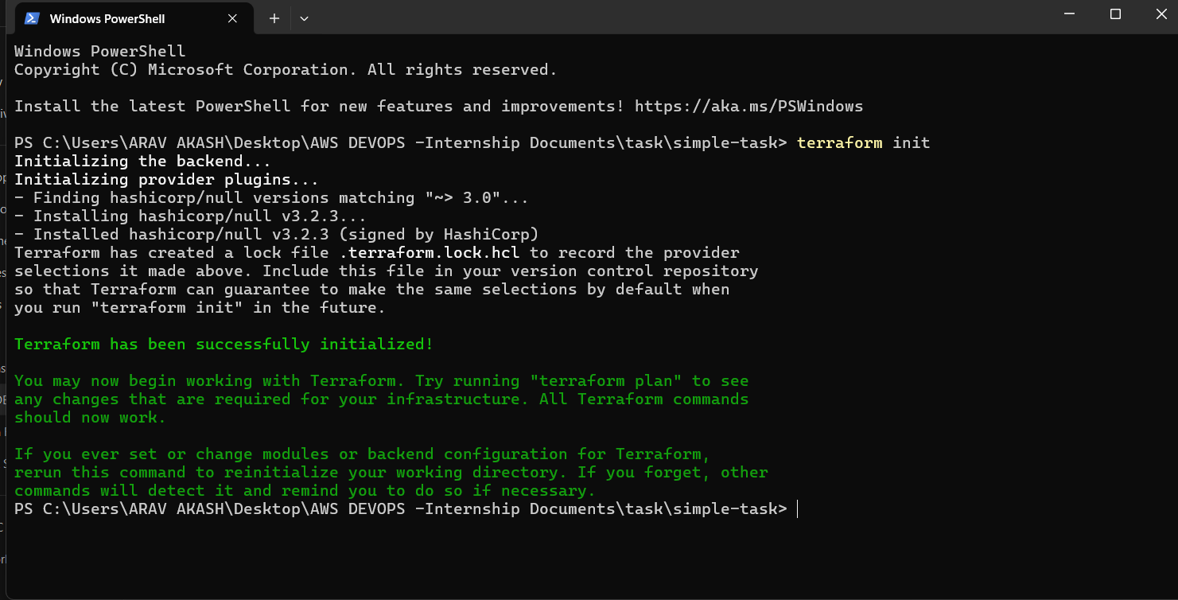

**Step 2: Preview the Execution Plan**

Before applying changes, I generate an execution plan:

terraform plan

Terraform displays the planned actions, indicating that it will create the null_resource.

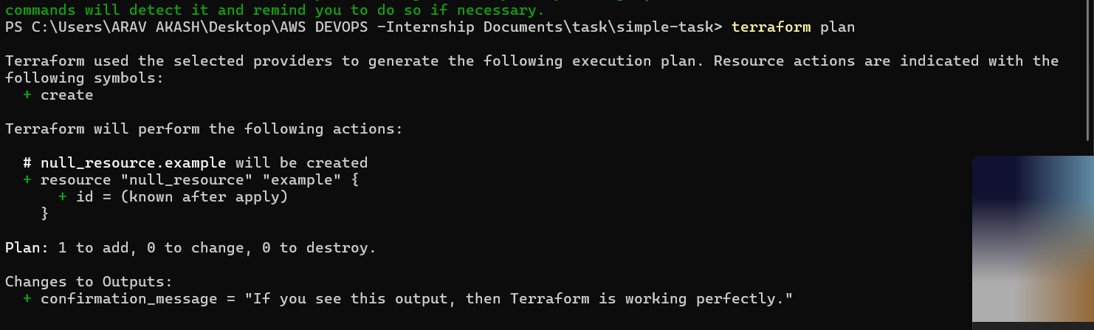

**Step 3: Apply the Configuration**

I then apply the changes to create the resources:

terraform apply

During execution, Terraform prompts me to confirm the action. I type yes to proceed. The local-exec provisioner executes the command, printing the message to my terminal.

**Step 4: Observe the Output**

After the apply operation completes, Terraform displays the output:

confirmation_message = "If you see this output, then Terraform is working perfectly."

This confirms that my configuration was executed successfully and that my setup is correct.

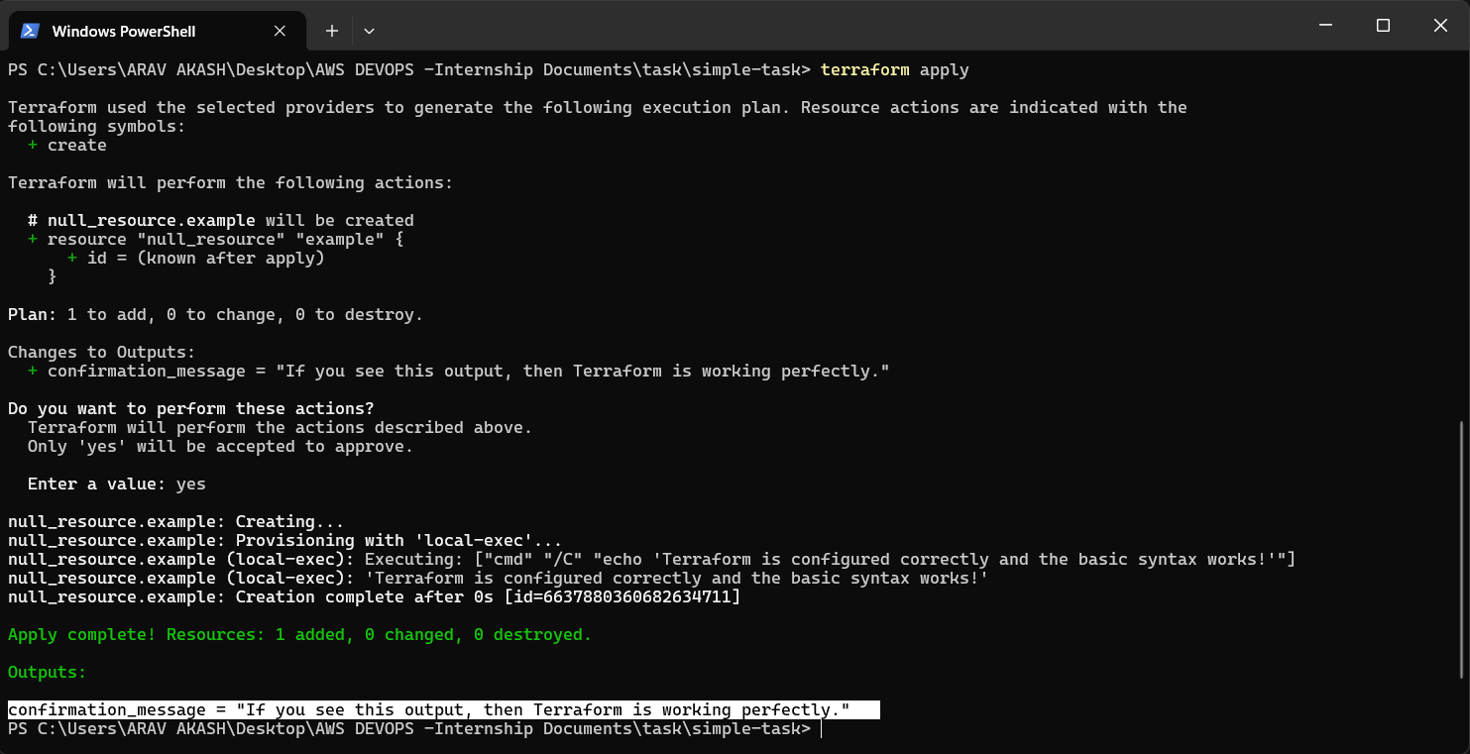

**3. What This Demonstrates**

By following these steps, I confirm:

* **Provider Configuration:**  
  My configuration uses the null provider, ensuring that I don’t need any external credentials or dependencies.
* **Resource Definition:**  
  I have defined a simple resource using a local-exec provisioner that runs a command, demonstrating basic resource creation.
* **Outputs:**  
  I defined an output to provide feedback and confirm that the configuration is executed as expected.

**Conclusion**

Terraform offers a robust and flexible solution for automating the provisioning and management of infrastructure. It integrates seamlessly into my DevOps workflow and supports a wide range of cloud providers.

* **Modules:** For creating reusable configurations.
* **Remote State:** To manage state files remotely, especially for team collaboration.
* **Workspaces:** To manage different environments (e.g., development, staging, production).